AIM:
To design and develop an Online Bus Pass Application System webpage using HTML and CSS featuring navigation links, image hotspots, and an embedded map of Tamil Nadu.

ALGORITHM:
- Create the basic HTML structure with <!DOCTYPE html>, <html>, <head>, and <body> tags.
- Add the page title and write internal CSS to style the header, navigation bar, panels, image, and footer.
- Design a header section displaying the title “Online Bus Pass Application System”.
- Create a navigation bar with hyperlinks for Home, Bus Routes, and Bus Stops that load in the iframe.
- Use a flex container to divide the webpage into left and right panels.
- Insert an image with defined hotspots linking to Tamil Nadu State Transport Corporation and embed a map of Tamil Nadu using Google Maps.
- Add a footer section, save the file with .html extension, and open it in a browser to view the output.

PROGRAM:
<!DOCTYPE html>
<html lang="en">
<head>
<meta charset="UTF-8">
<title>Online Bus Pass Application System</title>

<style>
body {
margin: 0;
font-family: Arial, Helvetica, sans-serif;
background-color: #f4f6f9;
}

header {
background: #1e88e5;
color: white;
padding: 15px;
text-align: center;
}

nav {
background: #0d47a1;
padding: 10px;
text-align: center;
}

nav a {
color: white;
text-decoration: none;
margin: 0 15px;
font-weight: bold;
}

nav a:hover {
text-decoration: underline;
}

.container {
display: flex;
padding: 20px;
gap: 20px;
}

.left-panel, .right-panel {
background: white;
padding: 15px;
border-radius: 8px;
box-shadow: 0 2px 5px rgba(0,0,0,0.1);
}

.left-panel {
width: 30%;
text-align: center;
}

.right-panel {
width: 70%;
}

iframe {
width: 100%;
height: 400px;
border: none;
border-radius: 5px;
}

img {
width: 300px;
height: 200px;
border: 2px solid #333;
}

footer {
text-align: center;
padding: 10px;
background: #e3e3e3;
margin-top: 20px;
}
</style>
</head>

<body>

<header>
<h1>Online Bus Pass Application System</h1>
</header>

<nav>
<a href="https://www.openstreetmap.org" target="display">Home</a>
<a href="https://www.openstreetmap.org/search?query=bus%20route" target="display">Bus Routes</a>
<a href="https://www.openstreetmap.org/search?query=bus%20stop" target="display">Bus Stops</a>
</nav>

<div class="container">

<!-- LEFT PANEL -->
<div class="left-panel">
<h3>Bus Route Map (Hotspots)</h3>

<!-- IMAGE MUST BE 300x200 -->
<img src="Image-1.jpg" usemap="#busmap" alt="Bus Route Map">

<map name="busmap">
<!-- Route 1 -->
<area shape="rect"
coords="10,10,140,90"
href="https://www.tnstc.in/OTRSOnline/"
target="display"
alt="Route 1"
title="Route 1">

<!-- Route 2 -->
<area shape="circle"
coords="220,120,35"
href="https://www.openstreetmap.org/search?query=bus%20stop"
target="display"
alt="Route 2"
title="Route 2">
</map>

<p><b>Tip:</b> Click the top-left rectangle or bottom-right circle</p>
</div>

<!-- RIGHT PANEL -->
<div class="right-panel">
<h3>Map Display</h3>

<iframe src="https://www.google.com/maps/embed?pb=!1m18!1m12!1m3!1d4012924.123838464!2d78.28976490000001!3d10.821166349999999!2m3!1f0!2f0!3f0!3m2!1i1024!2i768!4f13.1!3m3!1m2!1s0x3b00c582b1189633%3A0x559475cc463361f0!2sTamil%20Nadu!5e0!3m2!1sen!2sin!4v1770696818433!5m2!1sen!2sin" width="600" height="450" style="border:0;" allowfullscreen="" loading="lazy" referrerpolicy="no-referrer-when-downgrade"></iframe>
</div>

</div>

<footer>
© 2026 Online Bus Pass Application System
</footer>

</body>
</html>

OUTPUT:
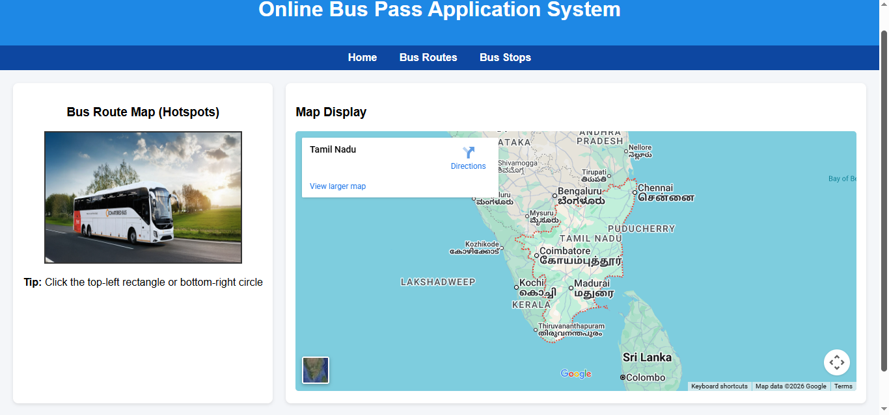

RESULT:
The Online Bus Pass Application webpage was created successfully and executed with working navigation links, image hotspots, and embedded map display.

